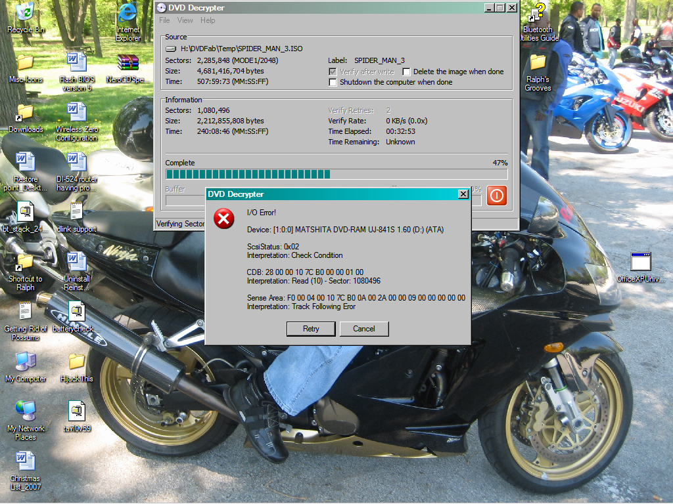

I’ve already used DVDFab Decrypter and DVD Shrink to create an ISO of Spider Man3. I can use VLC to play the ISO image with no issues, but when I try to use DVD Decrypter to burn the ISO image to (Maxell DVD +R or Memorex +RW) media, I receive an I/O Error. The ISO burn gets past the write stage in DVD Decrypter, but when it comes to the verifying stage, it will go for a little while, then the error occurs.

