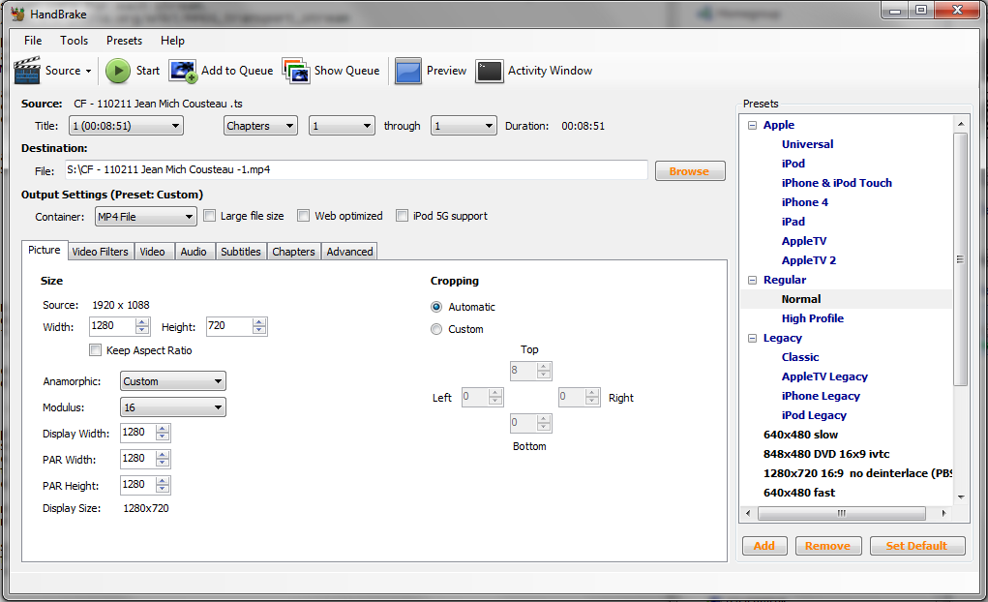
How do I get all these fields enabled, When I make my own Preset though it selects my custom made preset all the field that I have mentioned above still remain greyed out/disabled how do I get it enabled.
is this the arrow that you mean when you say “To get the new setting to show in "Display Size" I used the up arrow on PAR Width then the down arrow”

