I have two types of movie files in the USB PEN DRIVE
1st type: No problem with this

This is JFK Movie in .avi format and the associated sub title in the .SRT format.
Sony BDPs370 plays it with subtitles with no issues.
Conclusion, Sony BDPS370 can read the SRT format subtitle files.

2nd type : This is the problem

I have another file
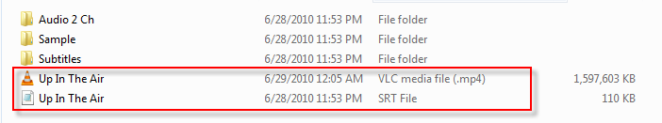
This is Uo in the Air Movie in .MP4 format and the associated sub title in the .SRT format.
Sony BDPs370 plays ONLY THE MP4 and NOT PLAYING THE SUBTITLE

I did some study in the internet and understood that, in MP4 format, the Video , Audio and Subtitles needs to be embedded as one single MP4 file , with the respective file format. So I used a tool named Yamp, this tool will pickup the video, audio and subtitile (.SRT) and mux them as Single MP4,
Please see the below screen capture

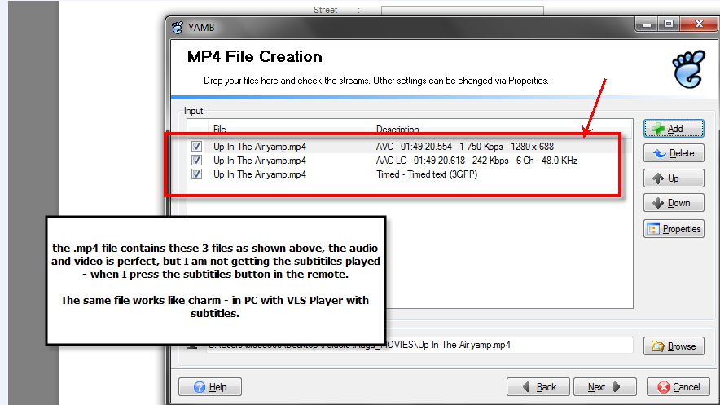

What I need?
- How to make the SUBTILE work with MP4 format?
- Why .SRT fie is working for .AVI and NOT WORKING for MP4?

